Workout Final Project Reflections

By: Alex Everitt, Mayur Ravji, Richa Srivastava

In this document, we will be discussing the application we have created for our final project. There are a couple things that I would like to preface before we get into the application and its functionality. Firstly, this was a collaborative effort; we did the work together, helping each other when necessary. For this reason, there is no piece of code that was written exclusively by one person. However, we were able to work around this by having one person be largely responsible for one aspect of the app, that break down goes as follows:

Richa: UI Design and navigation

Mayur: Firebase database and read/write capabilities

Alex: Fragments and data binding

Edit and delete functionality was a struggle with firebase as we have never done it before, so we all contributed to that equally.

The second thing that I wanted to mention was that this document will contain only screenshots on the app itself along with the functionality, there will not be any screenshots of code unless there is something specific that I want to mention. This document would be obscenely long if I tried to explain everything about the code.

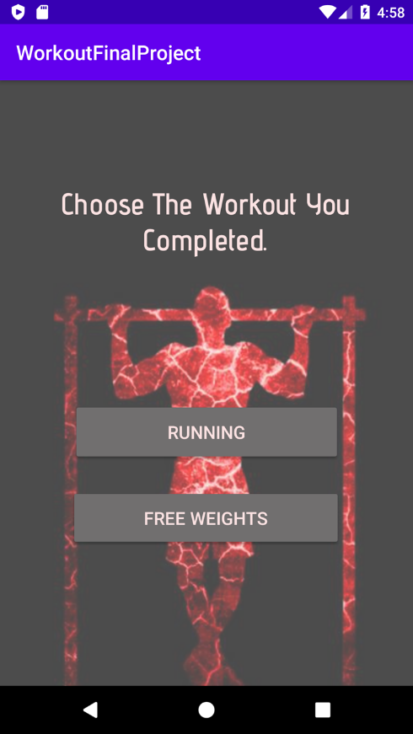Home Screen:

Our home screen is kept simple; we have some design aspects to make it more interesting and give it some character. The two buttons on the screen are the workouts that the user can complete. Once the user clicks a button, they will be directed to the appropriate fragment.

## Free Weights and Running Fragment:

These two fragments are where the user will be able to enter all the required information about the workout that they just completed. The top button adds the data to the firebase database once it has been entered. The lower button is where the user will be able to view all the past workouts they have completed.

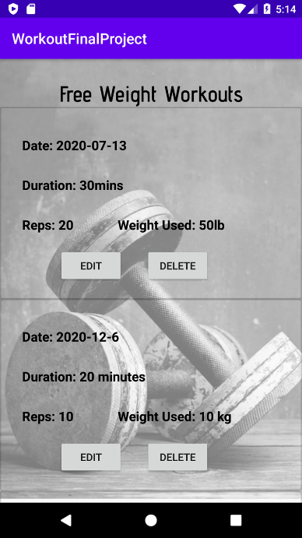

## View Past Workouts:

Here we decided to use a recycler view to be able to scroll through all the past workouts, and a card view to make the data easier to read and just more pleasing to look at. The card view also allows us to put buttons into the card itself making the editing and deleting of past workouts much easier to handle. In the next set of screenshots, we will look at editing past workouts.

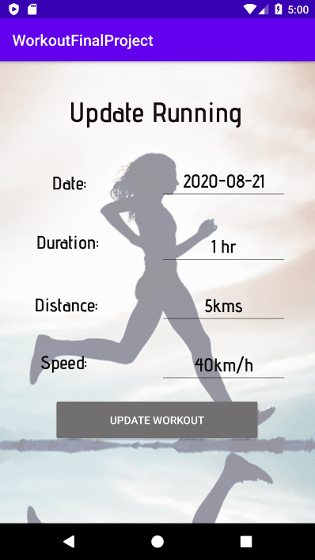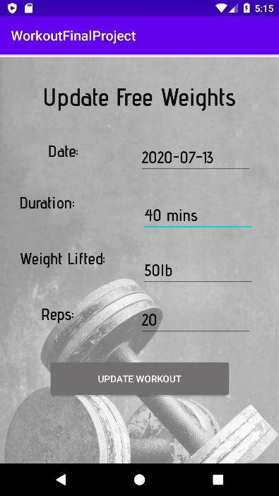

## Editing Past Workouts:

Once the user clicks the edit button, the app will redirect them to a fragment to edit the entry. The data is prepopulated with existing information, and the user can modify all the data as needed.

Once the user is satisfied with the update, they can click the update workout button. They will be automatically brought back to the past workouts screen and they will be able to see their newly edited workouts.

For the delete functionality I will not be demonstrating that in this document as it can be easily faked, and I would also like to encourage you to run and test our application as we are quite proud of the work that we have done. We have achieved most of what we set out to do, there are some things that we could fix that would make this application better. For instance, we do not validate inputs given by the user. We could add a hamburger menu for user preference settings or quicker navigation.

This project was a good learning experience as all of us have used room databases in android projects but some of our group has no experience using firebase. We took this opportunity to not only teach our group member how to work with firebase but it was also a good experience for the one doing the teaching as there is no better way to test your knowledge on a subject then to teach it to someone else.